Create a GUI similar to what is below. We will be using this to represent the information in our Bank Account program. The RichTextBox (not a listBox that we used in class) will show our end of the month data. On the bottom create buttons that will deposit and withdraw whatever is in the deposit/withdrawal textBox

Then another button to generate our end of the month statement. That will call the account class’s doEndOfMonth, except the doEndOfMonth() will be retrofitted to return a String not to just do Console.WriteLine…. Then this string will be appended to the RichTextBox.

You are welcome to do it any way you like. This is the general requirements we are going to need

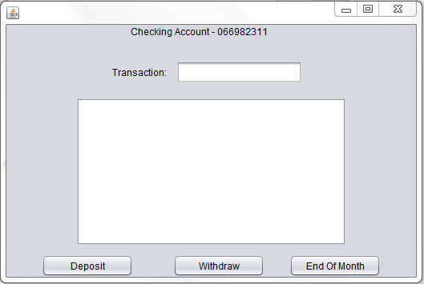

Buttons

RichTextBox

TextBox

Label

Label